# DAD 220 Cardinality and Targeted Data – Matt Bramer

Replace the bracketed text in this template with your screenshots and responses to the Module Four Lab for submission, grading, and feedback. Screenshots should be sized to approximately one quarter of a page. Written responses should be in complete sentences. Rename this document by adding your last name to the file name before you submit.

1. **Retrieve employee tuples** and **identify the number of employees in San Francisco and New York.**

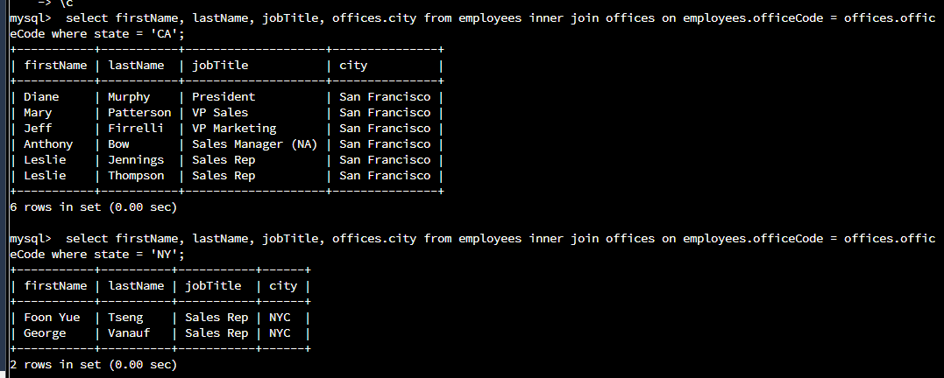

1. **Retrieve order details** for orderNumber 10330, 10338, and 10194 and **identify what type of cardinality this represents in the entity relationship model.**

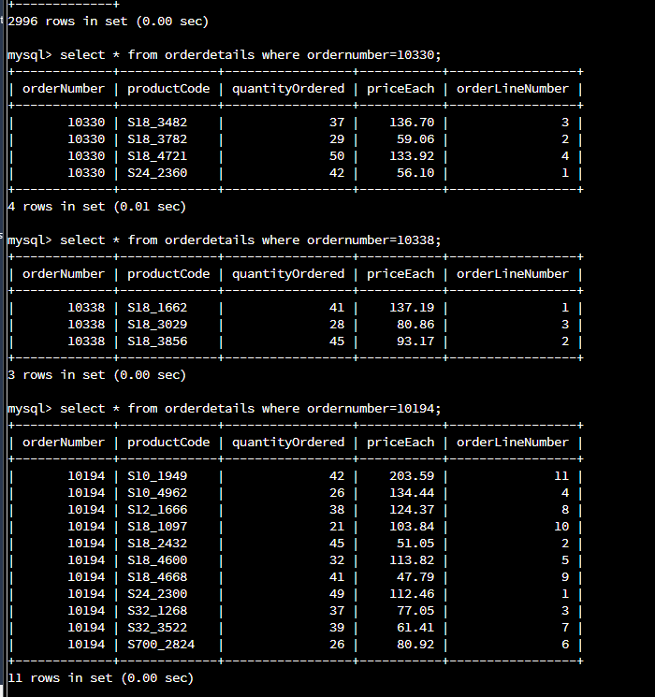

The cardinality for each of these orderNumbers is One-Zero or One, according to the iconography.

1. **Delete records** from the payments table where the customer number equals 103.

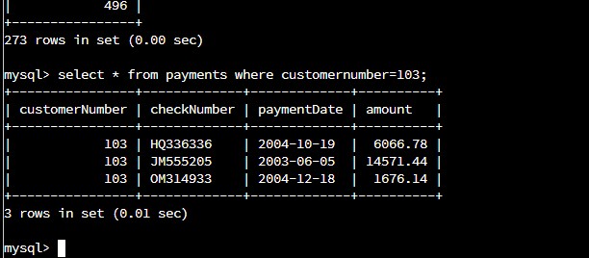



1. **Retrieve customer records** for employee Rep Barry Jones and **identify** if the relationships are one-to-one or one-to-many**.**



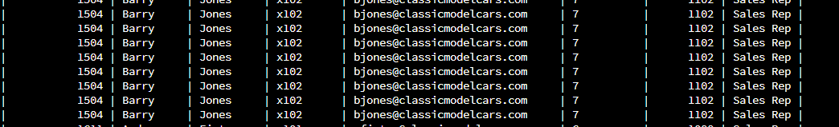

The relationship between employees and customers is one-to-many.

1. **Retrieve records for customers who reside in Massachusetts** and **identify** their sales rep and if the relationships are one-to-one or one-to-many**.**

The relationship is one-to-one, because they are specificially using the customers that live in Massachusetts.

1. Add one customer record with your last name using an INSERT statement. You may use the name of a celebrity or fictional character if you don’t use your own name.

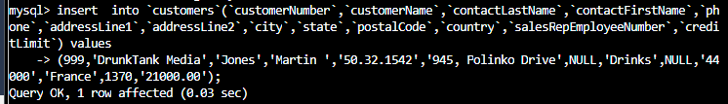

1. **Reflection**
   1. **Define how cardinality** is applied to the databases you’ve been working with and why different numbers of records returned from the different offices.

Cardinalities are great to understand when working with different records. There is one-to-one, one-to-many, many-to-many, zero-to-one, zero-to-zero. There is an incorrect relationship between products and orderdetails as there is Zero-Many Relationships should be crow foot, so as orderdetails to models there should be Zero or Many as well.

* 1. **Compare and contrast** the different queries you ran and how cardinality applies to them.

Between products, orderdetails, and orders there is a relationship where order details is the linkage between products and orders.

* 1. **Describe two of the crucial benefits of cardinality** in this type of database.

Provides intersection between tables since some tables cannot directly connect without linkage.